Midterm I Winter 2020

Data Science for Managers

Due by class: 2/18/2020

Submit an R Markdown for the following two problems. In order to get full credit, your R Markdown document must knit properly.

## Problem 1

Please write code that completes the following:

* Create a new variable for the departure hour from the scheduled departure time variable
* Calculate the number of flights that leave during each hour and each airport
* Draw a bar chart for each of the three New York airports
* Color the bars based on their origin airport
* It is not required that your graph replicate the graph labels. We will cover that in Chapter 28.

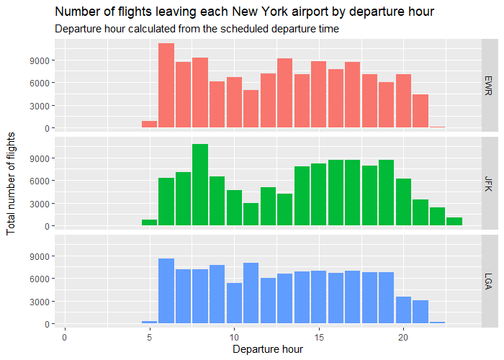 ## Problem 2

Please write code that completes the following:

* Determine the number of destinations for each NYC airport
* Create a bar chart that depicts the number of destinations
* Color the bars based on the departure airport
* Order the bars from smallest to largest number of destinations (This is called a Pareto Chart)
* It is not required that your graph replicate the graph labels. We will cover that in Chapter 28.

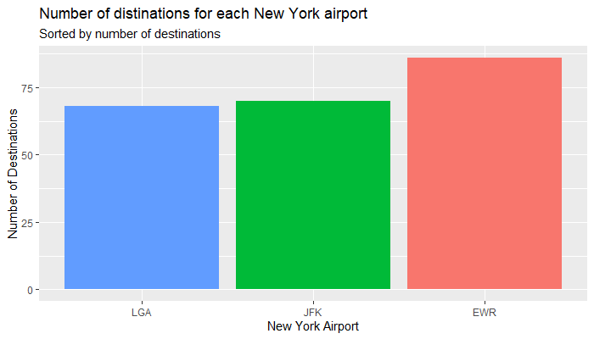

Create a similar graph